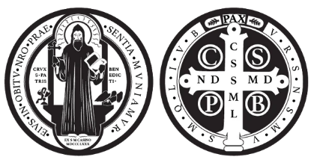
Spring Retreat
May 1 – May 3, 2026
St. Benedict Youth Ministry
Goochland, VA

What is it?
Spring retreat is a 3-day, overnight opportunity for High School aged youth to take a break from the world and enter into prayer and fellowship. We will have opportunities for Mass, Adoration, Confession, and prayer across the beautiful campus of the retreat center. There will also be times for small group discussions, group activities and games, sports, and other recreation.
When is it?
The retreat will be Friday, May 1 – Sunday, May 3, 2026. We will meet at St. Benedict on Friday evening and carpool to the retreat center together. We will return to St. Benedict on Sunday Morning in time for the 11am Mass, which we will attend together to conclude our retreat. Participants are expected to be present at the retreat center for the duration of the retreat (not leaving at night to return home or elsewhere).
Who can attend?
Youth who are in grades 8-12 are invited to attend. 8th graders who attend must be in their second semester of 8th grade. All youth in this age range are welcome, though prior participation in St. Benedict High School youth ministry is encouraged. Friends from neighboring parishes are welcome as always.
Where is it?
The retreat will take place at Camp Westview on the James, located in Goochland, VA, about a 45-minute drive from St. Benedict. Transportation will be arranged to and from St. Benedict. All are asked to gather at St. Benedict before and after the retreat, even if you are coming from the same direction, so as to allow for consistency of the experience and volunteer coordination.
What are the accommodations?
Youth will sleep in cabins with bunk beds. Mattresses will be provided, but bedding or a sleeping bag must be brought by each participant. Some cabins have attached bathrooms, some have a nearby bathhouse. Breakfast, lunch, & dinner on Saturday, breakfast on Sunday, and snacks will be provided by the retreat center. Dietary accommodations are available for gluten & dairy free, as well as some allergies.

How much does it cost?
The cost to attend the retreat is $75. This cost covers the price of the retreat center, meals, snacks, and a retreat T-Shirt. If the price provides a barrier for your participation, please reach out to Trevor Hamilton for information on offsetting the cost. Payments can be submitted at https://saint-benedict-catholic-church.square.site/
What’s the deadline?
The deadline to register and receive a T-Shirt is April 16.
The deadline to register without receiving a T-Shirt is April 24.
The cost remains $75 at either deadline.
How do I register?
You can register now by visiting this link: https://forms.gle/UfPpPX7uUYBNFKzN7
The registration link is also available on the Parish Website and Bulletin.
More information?
If you have questions about any of these details, registrations, or costs, please contact
Trevor Hamilton at thamilton@saintbenedictparish.org
More information, such as exact departure times, packing lists, and schedules will be available after your registration.

